Municipal budgetary educational institution
of the city of Alagir school №2.

Individual project

GUESTS,
SENT FROM ABOVE!

Completed by: 11thform student
Alina Kozaeva
Project manager: English Teacher
Irene Hadzhumarovna Cheldieva

2026
Content:
THE INTRODUCTION………………………..……………………………..…..2
THE CONCEPT OF TOURISM .……………………………………………….3
CHAPTER I.The history and development of tourism in Ossetia .……………4
1.1. Tourism in Ossetia now………………….…………………....………….……5
CHAPTER II.Places most visited by tourists in Ossetia ……………………….8
2.1. The route "Journey to the Clouds"……………………...……...……...….….15
  - . The route "Glaciers of Tsey"…………………………...……………......…...16
2.3. The route "From Unal to Tamisk"…………………………….…………...…17
THE CONCLUSION………………………………………………………….…29
THE INTRODUCTION

Tourism- a journey for pleasure or business, as well as the theory and practice of tourism, the business of attracting, accommodating and entertaining tourists and the business of organizing tours.
Actuality: the topic of tourism is very relevant in the modern world because it contributes to the development of the economy, the creation of new jobs and the improvement of the standard of living of the population.
The problem of the research: the popularization of tourism in our region.
The object of the study: the republic of North Ossetia-Alania.
The aims: 1. to find out the history of the origin of tourism 2. to analyze the prospects for the development of tourism in North Ossetia 3. to identify the places most frequently visited by tourists in Ossetia.
Hypothesis: is it possible to make tourism as one of the perspective directions of the development in our republic.
Tasks: 1. to study historical monuments, geographical objects of North Ossetia;
2. to plan, choose, evaluate ways of activity to solve problems related to the organization and conduct of hiking trips;
3. to analyze the mistakes made in the course of practical activity;
4. to contribute to the formation of a common culture among students, through familiarization with tourist and local history activities
Research methods: 1. observation. 2. photographing. 3. comparison.

CHAPTER I. THE THEORETICAL PART

  - The concept of tourism

Tourism- a social, cultural and economic phenomenon which entails the movement of people to countries or places outside their usual environment for personal or business/professional purposes. People who travel are called visitors (which may be either tourists or excursionists; residents or non-residents) and tourism has to do with their activities, some of which involve tourism expenditure.
Types of tourism are distinguished according to the target function, motives and results of tourism:
• sports
• recreational
• rehabilitation
• professional
• educational
• cultural
• entertainment
• excursion
• local history
• expedition
• business
• commercial
• combined
The tourism industry is complex and diverse, its main goal is the service of travelers. A product produced in the tourism industry, a tourist product, is a set of services that are consumed during travel, entertainment, treatment, training and other activities. The main components of the tourism industry and, accordingly, the tourist product:
• transport services
• accommodation
• auxiliary services
• sale
The main functions of tourism:
1. Promotes the restoration of human strength and ability to work and, accordingly, the psychological and physiological resources of society;
2. Promotes the rational use of people's free time;
3. Contributes to increasing employment and improving the living standards of the local population;
4. Tourism enriches the socio-economic infrastructure and interregional cooperation of countries, states, peoples.

1.2. The history and development of tourism in Ossetia

Travelling, respectively, and tourism have played an important role in the formation and development of world civilization. This process also affected the Caucasus. K.L.Khetagurov was the first who drew attention to the issues of travel and excursions conducted in the North Caucasus. Not being a specialist in the field of tourism, never engaged in organizing sightseeing activities, he noted the importance of recreation for the educational process, focusing on natural and social-ethnographic objects. After the establishment of Soviet power, the development of tourism and mountaineering became one of the main tasks of the Soviet trade unions. Considerable attention was paid to it in newspapers, magazines, news guidebooks were published, which took into account the already existing experience of pre-revolutionary authors, but the tourist and recreational activity itself had an ideological orientation.
Tourism in North Ossetia began to develop in the late XIX - early XX centuries. Ossetia attracted tourists that time as a resort area with numerous sources of various chemical composition, as an area with a large number of historical and archaeological monuments of antiquity, as an area with exceptionally favorable conditions for the development of mountaineering. Tourist and excursion activities intensified in the 20s of the XX century. Excursion and tourist organizations began to form, their material base was strengthened. In the pre-war period, the North Ossetian Excursion Department operated 4 camp sites for 390 places in Ordzhonikidze, Alagir, Tsey and Zaramag. After the Great Patriotic War, in the period from 1946 to 1951, the entire tourist economy was restored. The normal operation of all planned tourist routes has begun.In the 1950s and 1980s. North Ossetia was considered one of the centers of mass tourism. The functioning Committee on Tourism and Excursions owned 12 camp sites and 5 shelters, where 5,115 tourists could rest at the same time. Tourists were served both on All-Union and local routes. Tourists came to North Ossetia from all over the Soviet Union and, especially, from Astrakhan, Volgograd, Lipetsk, Saratov, Ulyanovsk, Voronezh and Rostov regions.
In 1921, the book "Methodology and technique of excursions" was published. The article "Towards the Knowledge of the Caucasus" reports on the study of its region, the study of the problems of history, geography, local lore, the author also suggests introducing regional history into the school curriculum. Announcements were often found in newspapers those years. The famous geologist Plemeevsky and the mountaineer Preobrazhenskaya led student excursions and hikes. They organized hiking trips to the mountains of Arauhoh, Fethuz, to the Black River, Sapitskaya Booth, etc. So, since 1927, outdoor games, competitions on elements of tourist equipment, various contests, amateur concerts have become popular in hikes and excursions. Climbing to Kazbek, hiking along Military Ossetian and Military Georgian roads,new camp sites and routes were opened in North Ossetia in early 30-40s. A mass ascentto the top of the Stolovaya Mountain took place in 1950 and about 350 participants took part there.
The Central Caucasus, the main part of which is occupied by the territory of North Ossetia is represented as the most interesting mountainous region of that time. Despite the fact that in the second half of the XIX century the Russian government considered it "not entirely desirable" for subjects of European states to appear on its territory, English, Italian, Austrian and Hungarian mountaineers made a number of record ascents to the peaks of the Northern Mountains Ossetia. In 1868, members of the world's first Alpine club, an organic founded in London (1857), under the leadership of Douglas Freshfield, she ascended the mountain Kazbek.

1.3. Tourism in Ossetia now

One can’t call North Ossetia a popular tourist destination because tourism in our republic is not on the level it should be. We are a republic with a unique nature. The republic is an important object to develop tourism. Residents of the region also show interest in the sights of Ossetia, because many of them are in involved in its industry. Tourism has great potential thanks to the untouched corners of nature, combining the historical monuments of Vladikavkaz and the North Ossetia-Alania in the whole. Tourism is a journey for pleasure or on business accommodation and tourists entertaining as well as organized tours.
North Ossetia, unlike Adygea and the Caucasian Mineral Waters, is not the most popular place for tourists. But this is exactly the reason why it is worth visiting Alania right now. Topaz mountain rivers are so transparent that if you put your hands in its waters, you can see the holes on the nails turn white. Wherever you go on vacation in North Ossetia — you’ll be served by traditional cheese pies. Attitude to guests is also special: they always will be treated with attention and hospitality.
Local guides providing you through stone canyons, cave fortresses and Midagraba waterfalls say that you’ll have a wish to come to these places more and more. A vacation in North Ossetia will fill you with impressions. The North Caucasus is a region that offers you almost all types of recreation. For those who love nature the following routes are offered: hiking to the most beautiful waterfalls and caves. For active tourists paragliding and rafting are available too. Horseback riding and excursions to eco-farms will be interesting for children. For those who need relaxation services of spa complexes will be pleasant and useful.

1.4. Places most visited by tourists in Ossetia.

1. Midagrabinskie waterfalls
They are considered to be the highest in Europe .The largest of them is the Big Zeigalan. The height of the continuous fall of water is 750 meters. According to the legend, if you stand next to it you can make a wish which must certainly come from the heart, this concentrated energy of water will quickly lift your goal into the universe. Knowledgeable people say that all your wishes and dreams may come true if you are open-hearted persons.
2."City of the Dead" Dargavs
A vacation to North Ossetia will be incomplete if you do not visit Dargavs — the business card of the republic and its best view from a postcard. The Ossetian city of the dead is under the patronage of UNESCO, but, to be honest, its best protection is its sacred history. The locals never visit this sacred placeas not to disturb the souls of the dead and do not come close after sunset. They have not been buried in Dargavs since the 30s of the 19th century, when the process of resettlement of mountaineers to the plain began. During the epidemic, in order not to infect other populations, the sick people voluntarily went there, built crypts. Now it is more a place of tourist pilgrimage.
3. Digoria
Two districts in the western part of the republic — Irafsky and Digorsky — are united by the name of Digoria and we called it the national Park "Alania". This is one of the youngest protected areas in Russia. It is not easy to get there, the national park is also considered the most isolated territory of North Ossetia. The road passes through the narrow mountain gorge of Ahsinta, which is replaced by the steep walls of the Digora gorge up to 300 meters high, and then the picturesque Zadalesky Valley opens. At the entrance to the valley you will see the Ossetian dzuar temple. You should stop before the temple and ask Uastyrdzhi for help, you may pray, leave a few coins as a gift, and then you may look round. All left money is collected and special people arrange a great feast on the name of Uastyrdzi.
4. Alan Holy Dormition Monastery
This monastery does not belong to the historical monuments of architecture — its main building was erected in 2000. However, the architectural style is corresponded to the Byzantine canons. Even the materials are selected in such a way that it seems as if this structure was erected several centuries ago, and natural stone was used in the construction process. Two watchtowers of the XVIII century have also been preserved, which became part of the entire ensemble. This monastery is located in the highlands, is an object of pilgrimage and one of the largest spiritual centers of North Ossetia and the entire southern part of Russia. Many tourist routes include a visit to the monastery. Guests here are offered infusions of medicinal herbs, you can take a photo of the exterior.
5. Tsey Gorge
Tsey Gorge is a natural attraction that stretches for 23 kilometers. The height of the gorge is 1300 meters. The gorge attracts an amazing beauty of nature, its fresh air. Comfortable recreation centres and ski resorts are organized here. There is no need to go to the Swiss Alps because the Republic of North Ossetia is an ideal place to meet all your wishes: a well-equipped ski complex in the mountainous region of Tsey. The tourist complex under this name can accommodate 320 guests. Ski routes for beginners amateur and advanced guests are at your service. Many sites with descriptions and photos of the sights of North Ossetia on the Internet include this complex as one of the main points for tourism.

CHAPTER II. THE PRACTICAL PART

2.1. The route "Journey to the Clouds"

Settlements through which the route passes: Vladikavkaz – Gizel village –Alagir -Tamisk- Misurs.Verkhny Mizur –Khod – Verkhny Zgid – Sadon – Nuzal –Vladikavkaz.
Day 1 Vladikavkaz – Mizur - Khod
You can get to the village of Mizur from Vladikavkaz by regular bus (the schedule can be viewed independently in search engines). Then you should go on foot.
At the end of the XIX century, Belgian entrepreneurs founded the village of Mizur. The extraction of silver leadthere was carried out at an intensive pace, and the workers needed somewhere to live. By this reason, a settlement was founded. That time or mining was a profitable business. Nowadays all the factories were closed. People lost their work. This time Mizur is a popular tourist destination. Nowadays many people find Mizur attractive for living, they choose fresh mountain air to improve health problems with lungs.

I would like to complete my tourist route to The Upper Mizur and the village Khurt. The name of Khurt was mentioned in the printed book «We are children of nature» written and translated by my English teacher Irene Cheldieva.

MY LITTLE BIRTHPLACE
I thank my lucky stars that I was born in the mountains. Mountains are like the sacred monastery. There is peculiar force here, it is impossible to be weak here, and we have to live just according to their laws. Maybe that’s why I live with the help of eternal beauty and I have no right to be weak.
My dear Ksurt! You are the birthplace of my beloved mother and her forefathers. You are so dear for me! My birthplace… Our deserted nest prepares me its arms with silent grief.
I always remember everything very excitedly. The famous generation of Baskaev family is from Ksurt. There are a lot of worthy people among them. There were huge losses of this famous generation, especially during the war. Though the settlement is deep in the mountains the aftermath of war came even here.
Now this Baskaev’s birthplace became an orphan. The last who left this place was my mother. This settlement cannot be compared with any other settlement in Ossetia. Alpine meadows, constantly green pine wood, here is medicinal water – the more you drink – the more you are thirsty. There are seven sacred places in the settlement. It was forbidden to have pigs here. It was considered the desecration of the land.
Today we respect and visit the sacred place Tkhost. In former days everyone from the settlement Ksurt gathered here and made a real holiday in honour of saint Tkhost.
My uncle Dzambolat told me that if someone was absent during the celebration of saint Tkhost he was considered dead. To visit the holiday was strictly necessary for everyone. The people from this settlement had to visit the holiday wherever they were. Even today we celebrate the holiday for the purification of the soul on the last Sunday of July. Only men may visit the sacred places and women stay at home and lay the table, this sacred place of Tkhost helps to realize one’s dreams.
I spent my childhood and secure youth in that place. Here is a patrimonial tower of my forefathers. It keeps the memory about the sacred land. You look and admire its greatness: the walls are sharply polished and there are huge stones on the very top. Who could build so? Could they be people-giants? I touch the walls of this tower with my chick, the tower which is washed by the secular rains.
My land – you are a real cradle of kindness, I love you immensely and I am proud of you. The warm stones of the tower inspire peace. There are still narrow streets which are covered with stones. I want to touch everything with the magic bacillus and to put life into everything to see that far saint world of my childhood.
The Baskaev’s love their little birthplace very much and I was also engrafted that love. Every stone of the blasted tower, of the house is dear to me, these proud tops of the mountains with the incomprehensible mystery and the fly of the rock eagles in the height, this crisp cold water is transparent like a tear.
The cradle of the spring feeds the stormy stream. Silence… the rank gardens, the fruit trees which were not taken care of for a log time, the thrown fences. The door of our house again is broken by the unkind persons. Only swallows found a shelter here. They say if the swallows make their nests in the house – this is happiness. But where is this happiness in my father’s house?! When I saw everything broken and destroyed and rambled, the tears welled up into my eyes. I think the people who came to our hospitable house not once do now such things. Why do they do so? The dead see and hear everything and the time will come when these people will be asked for everything. There is nothing left scot-free. With such melancholy thoughts I went farther from our house and I didn’t even notice the sky cover with silver clouds. They gathered in order to let the rains pour.
It was getting dark, the time was standing still and the black clouds were floating silently. And now it lightened. The pouring rain began and it became stronger and stronger. There was a fluffy tree in the corner of the broken house. The birds hid at the top of the tree pressing each other. I also hid and wasn’t wet at all. Everything knows here that such a rain stops very quickly. The sun appears again. Now it smelt with freshness everywhere, the birds began catching each other with jolly chatter.
After a long walk I came back home, sat on the bench which stayed untouched by wonder, and I fell into a doze under the kind beams of the setting sun. Suddenly through the somnolence I felt as the big and kind creatures were looking at me. It was our kind secular pear. It looked at me, listened to my sad thoughts with its leaves. I remember from my childhood as my father presented this pear the second life. Silently, under the calming affable crown I listened to the story about the bygone days, about the inhabitants of this house before us and about those who left this kind and hospitable house quite recently, about the wise old men who liked to sit on this bench, about different events in this settlement both joyful and bitter. So much time passed! And more about the kind hands which planted new fruit trees with which my pear beguiles its time. There was such warmth and magnificent kindness to people in these stories.
It is quiet around. It is getting dark. The first stars appeared in the sky. The bad thoughts didn’t leave me but I was glad to visit and to see my native places and to remember my childhood and youth. And now the whole world hid under the vaults of the mysterious twinkle of the stars and bright moon…
Day 2. After breakfast we go to the village of Verkhny Zgid. The village is located in the southwestern part of the Alagir district, on the left bank of the Skatta River.
After Zgid our way lies to the village of Nuzal. We will walk 3.5 km along the Sadonka River and reach the Traskavkaz highway, then about 3 km more and we are at the village of Nuzal.
Nuzal is one of the oldest mountain villages of North Ossetia (770 years). This is the former ancestral village of the famous Ossetian hero and military leader, the husband of the Georgian queen Tamara David-Soslan, a descendant of the ancient Ossetian tsars Tsarazonov. Here we will see an old medieval chapel built of rough stone slabs. The Nuzal chapel is surrounded by secrets – there is not much exact knowledge about it. It is not known, for example, when the chapel was built. Presumably, this is the second half of the XIII century. There is a version that it was built as a crypt and only later was converted into a temple, but there is no convincing evidence. The first mention of the religious building dates back to the XVIII century. It is also known that once the wall of the chapel was decorated with an inscription in Georgian, beginning with the words "we were nine brothers."
In the area of Nuzal, the walls and defensive fortifications of the ancient semi-black fortress are clearly visible on the rocks of the right bank of the Ardon river.
Here, at the walls of Nuzal, we finish our journey, and return back to Vladikavkaz by bus.
2.2. The route "Glaciers of Tsey"

Settlements through which the route passes Vladikavkaz – Alagir – Mizur – Buron village – The high-mountain resort of Tsey.
Day 1
Vladikavkaz – High mountain resort of Tsey.
You can get to the high-altitude resort of Tsey from Vladikavkaz by a regular bus which starts from the bus station No. 1 at 6:20. You will get to the point of your destination at 9:20.
We will pass some significant places such as the holy place of the Khetag’s Grove, the monument to Uastyrdzhi (patron saint of men), the mining village of Mizur and Zaramagskaya Hydropower station.
When you arrive at the place you should rent a room (better if you will do it beforehand because this place is overpopulated especially in a high season).
There are many sacred places in this Gorge. This place is connected with many legends and to be honest you should know how to behave and what you should know about the places you visit.
The sanctuary of the River is located in the Tsey gorge, near the village of Upper Tsey. Unofficially, it is considered the main male sanctuary of Ossetia, women are not allowed to enter there. The sanctuary is built by the River and it is a wooden construction built of larch trees without using nails. It is forbidden for everyone to carry out anything from this sacred place.
On the day Kæhtsgænæn this great holiday is devoted to all boys who were born in the following year. Boys are considered to be the followers of the family and the genus.
After visiting the Recom, we move to the chairlift.
The Skazsky glacier in the Tsey Gorge descends the slope of Mount Aday-Hoh (4408 m). Its size is small, but it is the only glacier in the Caucasus that can be reached by a ski chairlift. All people can approach the lower tongue of the glacier, without training and climbing equipment.
The Tsey gorge has a length of 15 kilometers, and the last 4 kilometers are divided into two parts by Mount Monk (2990 m). This mountain forms the famous Tsey Horseshoe. In the northern branch of the horseshoe, the Tsey Glacier descends into the gorge. This is one of the largest glaciers in North Ossetia. The Skazsky Glacier descends along the southern part of the horseshoe into the gorge. A chairlift has been laid from the Tsey Alpine Camp to the Skazsky Glacier. The climb is 1 kilometer. The chairlift rises above the Skazdon River, which originates in the Skazsky Glacier. In winter, there are three ski trails and two ski chairlifts. In summer, one chairlift works for people who want to go up to the glacier for a walk. There are no trekking trail in this part of the gorge, but if you want to make a steep climb, then you can go along the ski slopes. However, it makes no sense, since the climb is too high. The lower station is located at an altitude of 1850 meters, and the upper one is at an altitude of 2870 meters. The lift has one intermediate station. From the intermediate to the upper station, the mountain slope becomes even steeper. In winter, a black ski trail is laid here.
Near the upper station there is a path where you can approach the Skazsky glacier. It is not long and there is no climb. Below you will see a huge glacier moraine and a grotto where the Skazdon River originates. There is also a path to this grotto. If you have time, it`s worth a walk there. Some tourists go inside the grotto, but it is very dangerous. The glacier is melting, chunks of ice and large stones are constantly falling from above. It is not recommended to approach the grotto closer than 30-50 meters. The lower part of the Skazsky glacier is located at an altitude of 2900 meters. To the south of the chairlift, the mountains of the Tsey Ridge rise. The height of its mountains exceeds 3500 meters. Most of the year the peaks of the ridge are covered with snow. Above the glacier at an altitude of 3910 meters there is a pass between the mountains Aday-Hoh and Lagau.
After visiting the Tseysky glacier, we return to the place of the overnight stay, we should collect our equipment and hurry up to the bus which departs at 5 in the evening from the High-altitude resort.

2.3. The route "From Unal to Tamisk".

Settlements through which the route passes: Nizhny Unal village-Verkhny Unal village - Tsamad village-Ursdon village-village Zintsar - Tamisk settlement - Alagir city
Day 1. We start our journey from the village of Nizhny Unal. The village of Nizhny Unal is located in the central part of the Alagirsky district, on the right bank of the Ardon River, at the confluence of the Kutardon and Mayramdon rivers into it. It is located 22 km from the district center of Alagir and 58 km southwest of Vladikavkaz. The battle tower of the Tsallagov family has been preserved in the village.
Five-six-storey ancestral towers in North Ossetia were built only by the noble, who proved themselves from the best side of the family. Permission for this was given to them by the council of elders of the surrounding villages. The council took into account not only the authority, but also the financial viability of the family. Towers were built of stones, and in those days they were very expensive building material. The white stone was most valued.
One of the most majestic natural phenomena of the village of Tsamad is the terraces, reaching a height of up to 130 meters. For a long time it was believed that terraces are the fruit of anthropogenic human influence. However, in 2009 it was proved that the terraces of the Ursdon Gorge are the consequences of the gradual melting and retreat of the glacier (the shores of a prehistoric ancient lake).
Dagom village is another ancient settlement of the Alagir gorge, the foundation of which is also attributed to the descendants of Os—Bagatar. According to oral tradition, they lived here in contentment and wealth. In Dagom, over time, "there were so many houses that you could run from one side of the village to the other on their roofs." Of great interest is the sanctuary of Zeyrond Uastyrdzhi dzuar located on the outskirts of the village (translated from Ossetian — the Ancient sanctuary of Uastyrdzhi), which was a small chapel built on top of a huge free-standing stone. According to experts, this sanctuary was purely military in nature: after a feast held near it, detachments of soldiers went on a campaign from there. These peculiar squads were formed at the rate of one man from each yard. Moreover, the oldest and youngest man of each house was forbidden to participate in the campaign.
A picturesque place where clouds embrace the peaks of mountains, mountain streams flow. Archaeological monuments have been discovered in the Ursdon gorge of the Alagirsky district, testifying to the appearance of the population here, long before the arrival of the Alans. The settlement of these places was facilitated by fertile lands for cattle breeding and terraced farming, favorable natural and climatic conditions, as well as a strategically convenient position, which makes it possible not only to live safely, but also to control the passes and caravan routes crossing these mountainous areas. The population of the Bronze Age left here the Tsamad burial ground of the XII-X centuries BC of the Koban cultural and historical community. Dagomsky Alan catacomb burial ground began functioning in the VI century. Some finds indicate the probability of the beginning or the 1st quarter of the VI century. The first catacombs were laid, apparently, at the western end of the 2nd terrace (plot 2), from where the filling of the burial ground began, however, we cannot reliably assume a strict time sequence of filling the burial field from west to east due to its insufficient research and the possible existence of local ancestral or family plots.
If you want to stay there for a night you should take care of your supper and have a tent to spend a night there.
Day 2. In the morning after breakfast, we head towards the village of Zintsar, observing the former Greatness along the way. Finally, in the distance, under a sheer rock wall - a rocky ridge justifies its name - Ursdon appears.
Ursdon (from oset. "white river") is a village in a side branch of the Alagir gorge) at the foot of Mount Cariu. The village is located on the bank of a clear, bubbling river, whose water seems white due to the flow along the white limestone bed. All natives of Ursdon, according to ancient folklore legends, are descendants of the legendary Os-Bagatar. Researcher of the history and culture of the Ossetian people Pchelina E.G. writes: "When the offspring of the middle son of Tsakhil grew up, they moved to the area that later became known as Jarond Ursdon (ancient Ursdon). Among the ruins of the residential quarters of Ursdon, the Dzugaev battle tower and the Dzigasov battle tower have been preserved. In the upper part of the village is the sanctuary of the patron saint of the village. The main attraction of Ursdon is the rock fortress – the pearl of defensive architecture of Ossetia. The fortress is located on the right bank of the Ursdon River, about 200 meters northwest of the abandoned right-bank part of the village, at an altitude of 100-150 meters above the river level; It is a whole system of defensive fortifications, some of which are covered with protective walls of natural caves adapted for the needs of defense and housing. The fortress was fortified with 5 battle towers. The main and especially revered sanctuary in Ursdon was Migdau dzuar (Migdau – "powerful", "patron of clouds").
On the right bank of the Ardon River, near the village of Biz, there is a "Chyramad Gate" (translated from Ossetian – a wall made of limestone) in the form of a massive pointed arch. These are the remains of a customs outpost. There was an ancient passage built of stone, which was closed by “heavy wooden gates". This unique stone arch of the 17th century, the only one preserved of seven similar ones. Chyramad was guarded by the inhabitants of the gorge under the control of the powerful and influential Tsakhilov family. Since ancient times, this trade route has played an important role in the relations between Russia and the south of the Caucasus. One of the Silk Road routes passed here. Behind them, in the rock, there is a semi-black canopy, which served as a shelter for the sentries standing guard here.
Tamisk. A large limestone deposit with a reserve of more than 95 million tons is located in the Tamiskdon River Valley. The rocky ridge is a kind of natural reservoir for collecting atmospheric moisture, which comes out through interplastic cracks at the foot of the ridge, flowing down in rivulets of cold transparent spring water.
At the foot of the Rocky Ridge at the confluence of the small river Tamiskdon with the Ardon, there is a balneological resort of North Ossetia "Tamisk". The Tamisk deposit of mineral waters belonging to the type of hydrogen sulfide, calcium-magnesium sulfate serves as a material and therapeutic base for it. These waters have been known since time immemorial and attracted the attention of the population of Ossetia for their healing properties. There has been a legend among the Ossetian people for a long time that there are sources of miraculous water high in the mountains, accessible only to eagles.
Tamisky mineral springs contain hydrogen sulfide up to 65 mg per liter. Their gas composition is dominated by free hydrogen sulfide. The springs belong to cold waters, since their temperature does not exceed 16 °. In addition to natural outlets, the mineral hydrogen sulfide waters of the Tamisky deposit were brought to the surface by a well with a maximum depth of 1016 m. According to the conclusion of the Central Research Institute of Balneology, the borehole waters of the Tamisky deposit are analogs of the main Matsesta waters, and in ionic composition and total mineralization they are close to the Sergiev mineral waters. The waters of the Tamisky deposit are valuable therapeutic waters, the physiological and therapeutic effect of which is determined by the presence in therapeutic concentrations of highly active sulfides (free hydrogen sulfide and hydrosulfite ions.). We can leave Tamisk taking a bus.

THE CONCLUSION

Previously, in Soviet times, there were many routes in Vladikavkaz. There were camp sites in Vladikavkaz, Alagir, Fiagdon, and Tsey. Everything new is a well-forgotten old. Therefore, you can use the old routes or the new ones I have suggested.
We can talk about this forever, but I will focus on the development of tourism in my area, as this is an opportunity to develop infrastructure, it provides additional jobs for young people, it attracts more and more tourists, increases the cultural level of our nation, and also makes a huge contribution to the development of foreign languages.

LIST OF LITERATURE AND REFERENCES

- https://turist15.ru/routes/marshrut-puteshestvie-k-oblakam
- https://revistaderechocultura.es/
- https://caucasushistory.ru/2618-6772/article/view/1875
- Б.М. Бероев «По Северной Осетии», 1984 г.
- К.П.Попов «Путешествие в древний Иристон», 1995 г
- https://www.instagram.com/tsey_kurort/
- https://ru.wikipedia.org/wiki/Цей
- https://www.tourister.ru/world/europe/russia/city/verhnii-cei/snow/31689
- https://turisticum.ru/cey/

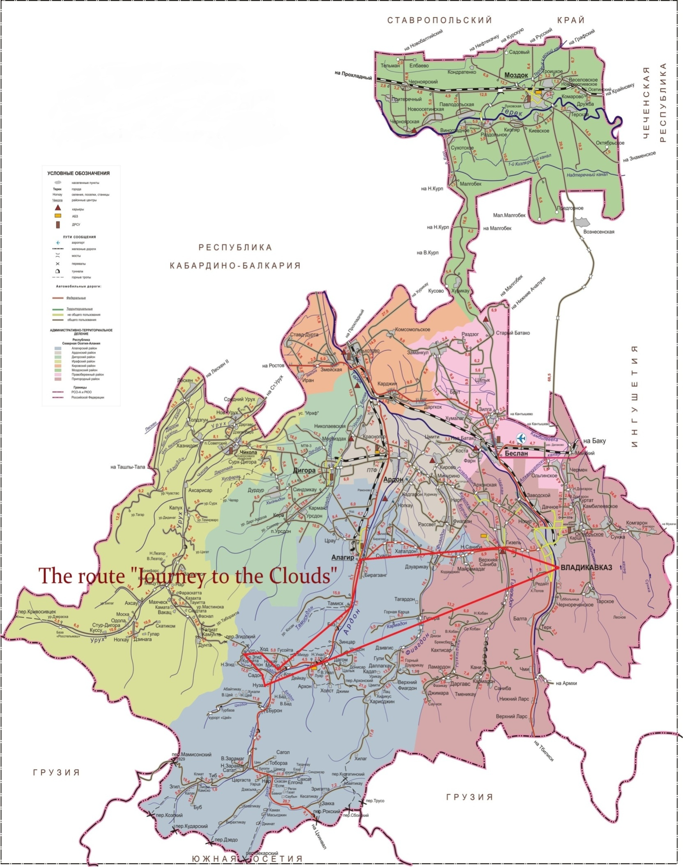
Appendix 1.
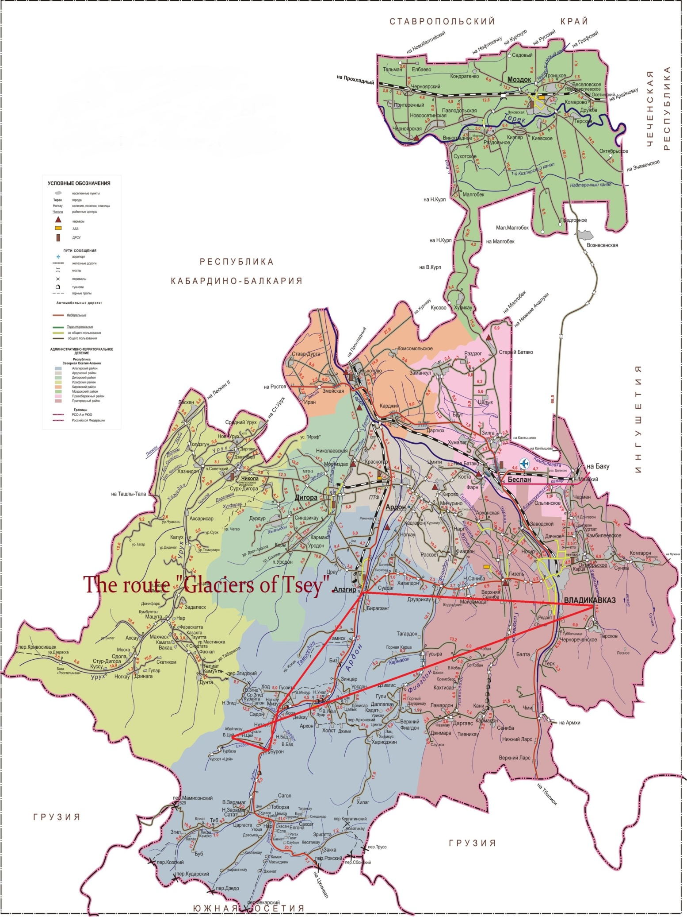
Appendix 2.
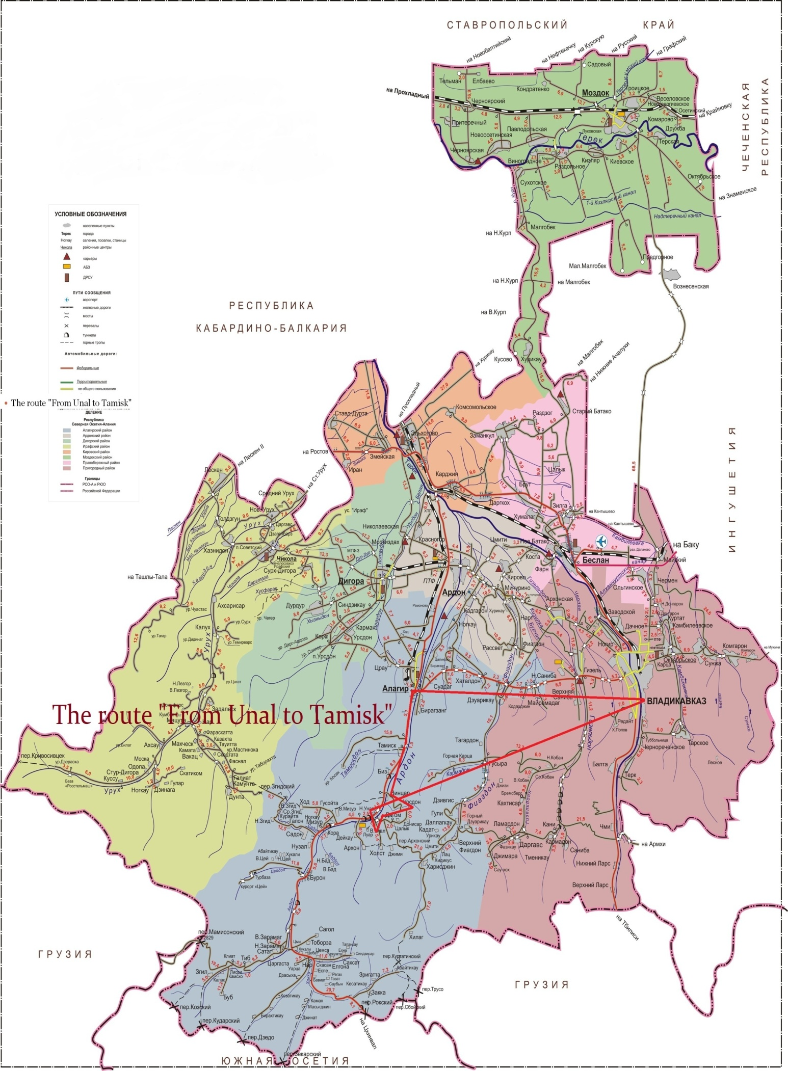 Appendix 3.

https://revistaderechocultura.es/
https://www.tourister.ru/world/europe/russia/city/verhnii-cei/snow/31689
https://caucasushistory.ru/2618-6772/article/view/1875
cei/snow/31689

